Bell Work: PART 1
Answer the following questions based on who you are today:
1. How would you describe yourself?
2. How do your friends, family and teachers describe you?
3. How would strangers describe you in passing (at a first glance)? What judgments would they make about you?
4. What aspect of your life has influenced you the most?
________________________________________________________________________

Wait, Stop Here: PART 2
Answer the following questions based on the note card you received:
1. How would you describe yourself now?
2. How would your friends, family and teachers describe you?
3. How would strangers describe you in passing (at a first glance)? What judgments would they make about you?
4. What aspect of your life has influenced you the most?

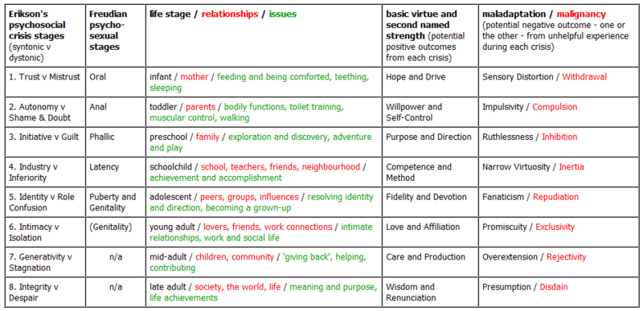

  - Dictionary Helper:
Latency: sexual urges are dormant
Virtuosity: a taste for or interest in
Inertia: a feeling of not having the energy or desire that is needed to move, change, etc.
Fanaticism: fanatic outlook or behavior especially as exhibited by excessive enthusiasm, unreasoning zeal, or wild and extravagant notions on some subject
Repudiation: the state of refusing to have anything to do with

Erik Erikson and Identity Formation
Review: Erik Erikson’s Theory of Psychosocial Development.
Erikson’s theory consists of _______. Within each stage a ______ must be resolved.
This crisis is a major ________ issue that becomes important during a _____ time period
throughout one’s life. In order to be successful at solving this crisis, one must balance
________ and a corresponding ______ trait. In most situations the ______ traits prevail.
However, Erikson did believe that ______ traits are needed as well.
Example: In infancy, the crisis is_____________. People need to learn to trust the world
around them but in order to do this; they also need to learn about _______ to ______
themselves from danger.
_______ of Erikson’s theory is identity formation, which begins in _________. The
crisis in this stage is known as _______ vs. _______________ which is also known as
____________. During this stage adolescents are attempting to ________ of
______________ and what their ____________ is in society
Erikson’s Theory on Identity Formation
Identity is ____ formed by mimicking others. It is formed by taking _______________
about identity, ____________ and __________ those ideas into a ____ structure.
The _______ of three main areas is key to resolving conflicts in identity formation. They
are choice of ________, the adoption of _______ to live by and believe in and the
development of a satisfying ____________.
When the crisis in stage 5 is successfully resolved, it is known as ________. When this
occurs, individuals have developed a _________ loyalty, faith, or a sense of belonging to
a loved one or to friends. It can also mean ___________ with a certain set of values,
religious group, political group, etc.
Factors that Can Influence Identity Formation
There are multiple _______ that can influence identity formation. The first factor is
________ since males and females form their identity through _______ ways. ________
form their identity through _________________ while men do not. This usually occurs
since women tend to have ______ self esteem than men.
The next factor is ______. Identity formation is extremely _________ for members of a
minority group. ________________ can greatly influence an individual’s __________.
The final factor is ______________. __________ makes it difficult for individuals with
a sexual orientation that differs from the ________________. ______________ and
_________________ are huge factors here.
Problems Associated with Erikson’s Theory Erikson considered _____ identify formation to be the _____. He stated that _____
formed their identity through __________ while ____ could not be involved in intimacy
until ________ their identity had been fully formed. This is why many _______
Erikson’s theory as the truth and simply use it to __________.

